PIZZA SALES SQL QUERIES

1. KPI’s
2. **Total Revenue:**

SELECT SUM(total_price) AS Total_Revenue from [pizza_sales (1)]

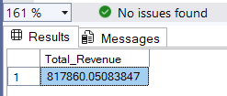

1. **Average Order Value:**

SELECT SUM(total_price) / COUNT(DISTINCT order_id) AS Avg_order_value from [pizza_sales (1)]

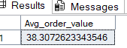

1. **Total Pizza Sold:**

SELECT SUM(quantity) AS Total_Pizza_sold from [pizza_sales (1)]

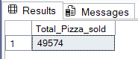

1. **Total Orders:**

SELECT COUNT(DISTINCT order_id) AS Total_Orders from [pizza_sales (1)]

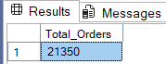

1. **Average Pizzas Per Order:**

SELECT CAST(CAST(SUM(quantity) AS DECIMAL(10,2))/

CAST(COUNT(DISTINCT order_id) AS DECIMAL (10,2)) AS DECIMAL(10,2)) AS Avg_Pizzas_Per_Order from [pizza_sales (1)]

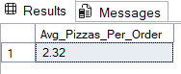

1. DAILY TREND FOR TOTAL ORDERS:

SELECT DATENAME(DW, order_date) as order_day, COUNT(DISTINCT order_id) AS Total_orders

from [pizza_sales (1)]

GROUP BY DATENAME(DW, order_date)

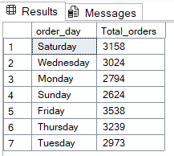

1. MONTHLY TREND FOR ORDERS:

SELECT DATENAME(MONTH, order_date) AS Month_Name, COUNT(DISTINCT order_id) AS Total_Orders

from [pizza_sales (1)]

GROUP BY DATENAME(MONTH, order_date)

ORDER BY Total_Orders DESC

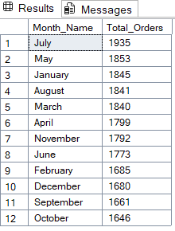

1. % OF SALES BY PIZZA CATEGORY:

SELECT pizza_category, SUM(total_price) as Total_Sales, SUM(total_price) * 100 /

(SELECT SUM(total_price) from [pizza_sales (1)] WHERE MONTH(order_date) = 1) AS PCT

from [pizza_sales (1)]

WHERE MONTH(order_date) = 1

GROUP BY pizza_category

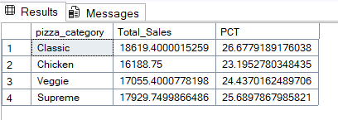

1. % OF SALES BY PIZZA SIZE:

SELECT pizza_size, CAST(SUM(total_price) AS DECIMAL (10,2)) as Total_Sales, CAST(SUM(total_price) * 100 /

(SELECT SUM(total_price) from [pizza_sales (1)] WHERE DATEPART(quarter, order_date)=1) AS DECIMAL(10,2)) AS PCT

from [pizza_sales (1)]

WHERE DATEPART(quarter, order_date)=1

GROUP BY pizza_size

ORDER BY PCT DESC

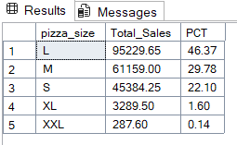

1. TOTAL PIZZAS SOLD BY PIZZA CATEGORY:

SELECT pizza_category, SUM(quantity) as Total_Quantity_Sold

FROM pizza_sales

WHERE MONTH(order_date) = 2

GROUP BY pizza_category

ORDER BY Total_Quantity_Sold DESC

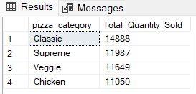

1. TOP 5 PIZZAS BY REVENUE:

SELECT TOP 5 pizza_name, SUM(total_price) AS Total_Revenue

FROM [pizza_sales (1)]

GROUP BY pizza_name

ORDER BY Total_Revenue DESC

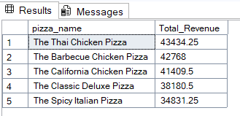

1. BOTTOM 5 PIZZAS BY REVENUE:

SELECT TOP 5 pizza_name, SUM(total_price) AS Total_Revenue FROM[pizza_sales (1)]

GROUP BY pizza_name

ORDER BY Total_Revenue ASC

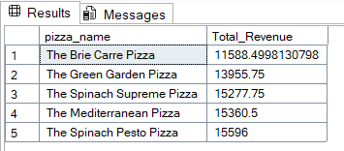

1. TOP 5 PIZZAS BY QUANTITY:

SELECT TOP 5 pizza_name, SUM(quantity) AS Total_Quantity

FROM [pizza_sales (1)]

GROUP BY pizza_name

ORDER BY Total_Quantity DESC

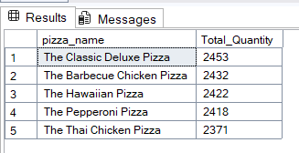

1. BOTTOM 5 PIZZAS BY QUANTITY:

SELECT TOP 5 pizza_name, SUM(quantity) AS Total_Quantity

FROM [pizza_sales (1)]

GROUP BY pizza_name

ORDER BY Total_Quantity ASC

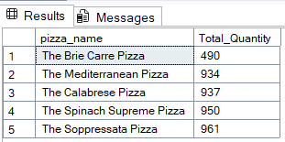

1. TOP 5 PIZZAS BY TOTAL ORDERS:

SELECT TOP 5 pizza_name, COUNT(DISTINCT order_id) AS Total_Orders

FROM [pizza_sales (1)]

GROUP BY pizza_name

ORDER BY Total_Orders DESC

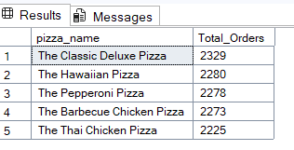

1. BOTTOM 5 PIZZAS BY TOTAL ORDERS:

SELECT TOP 5 pizza_name, COUNT(DISTINCT order_id) AS Total_Orders FROM [pizza_sales (1)]

GROUP BY pizza_name

ORDER BY Total_Orders ASC

